**Facts & Tips About the CPM Textbook**

(www.cpm.org)

**Symbols & What They Mean**:

No Calculator can be used Where HW problems will start…

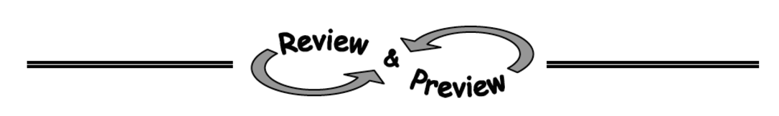(must be worked out by hand)

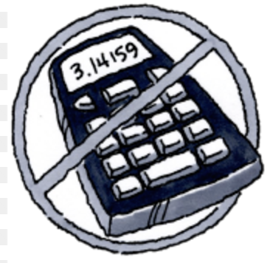

__________________________________________________________________________________

Notes Boxes that explain topics HW Problems are labeled by “**Ch # – Prob. #”**

in more depth… For example, below is **Ch. 7** problems **67** and **68**.

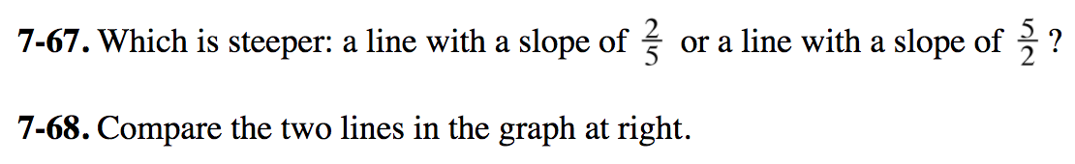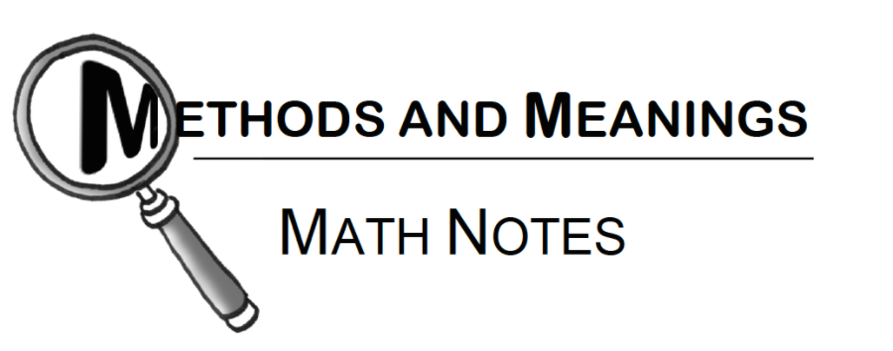

__________________________________________________________________________________

Problems labeled with a “ **CL *#*** ” are what we call “closure problems” and they can be found at the end of each chapter. Closure Problems will always have answers directly in the book a few pages after the closure problems, that way students can check their answers to make sure they are on the right track! *(As an example, below are Closure Problems for Chapter 1 # 64-66.)* 🡻

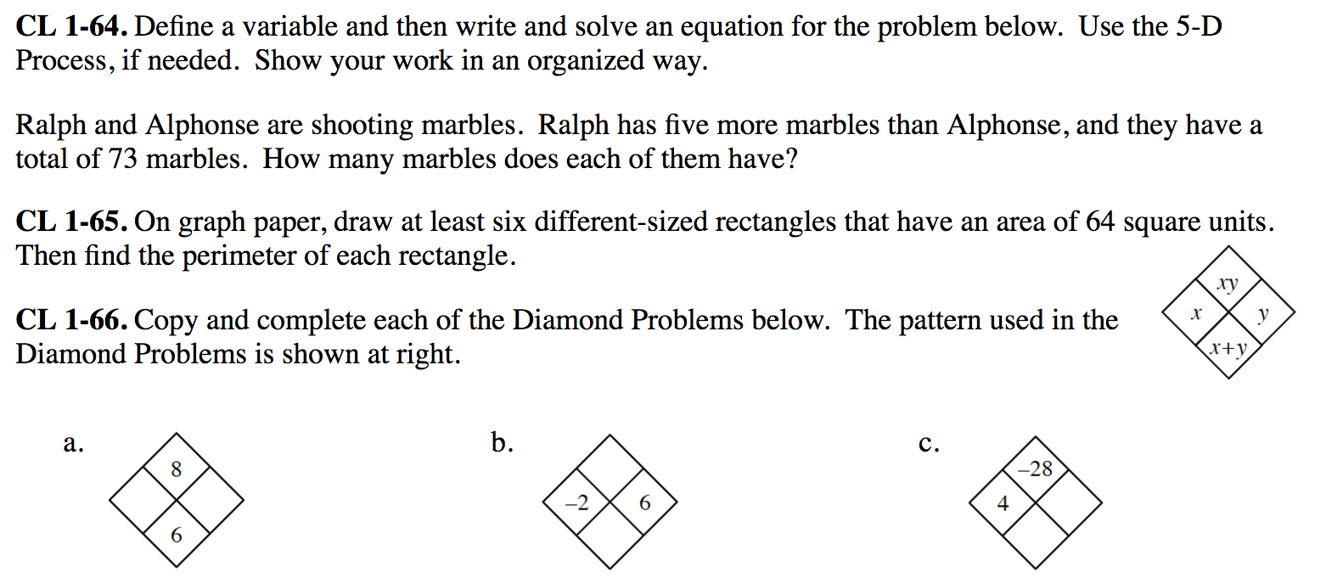

There are also **Math Vocabulary Boxes** that list important vocab words and topics for each chapter. These boxes can be found and END of each chapter. The definitions to these words/topics can be found in both the chapter itself and the index/glossary in the back of the textbook.

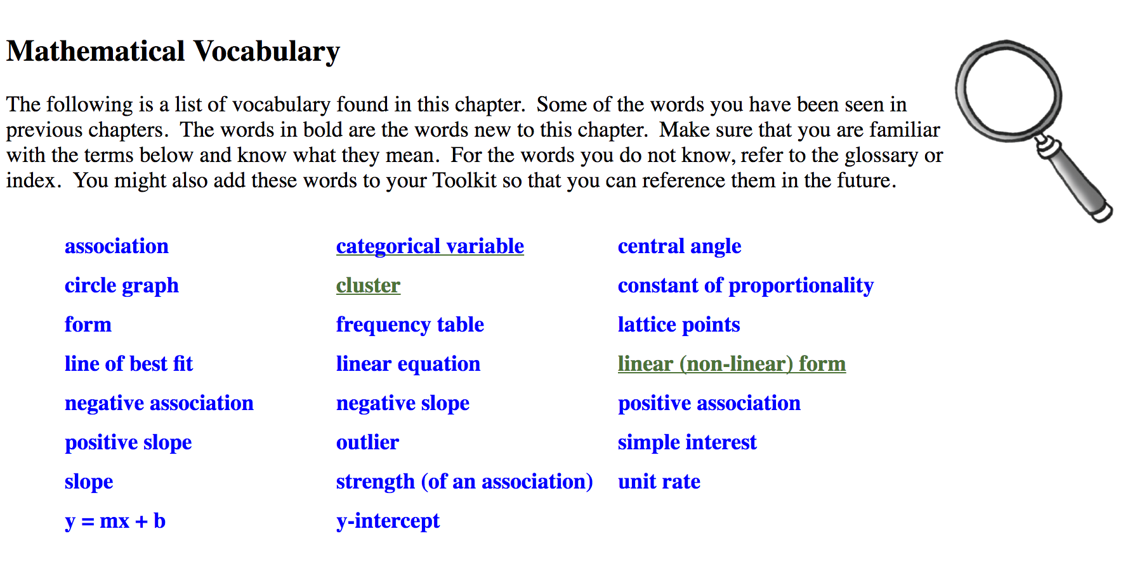

Sections for each chapter are labeled using **3 Numbers**.

The first # is the chapter, the second # is the section, and the third # is the part.

The examples below can be read like this: “***Chapter ___ . Section ___ . Part ___ .***”

**Chapter 1, Section 1, Part 2:**

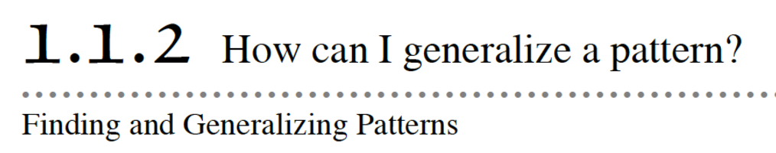

**Chapter 1, Section 1, Part 4:**

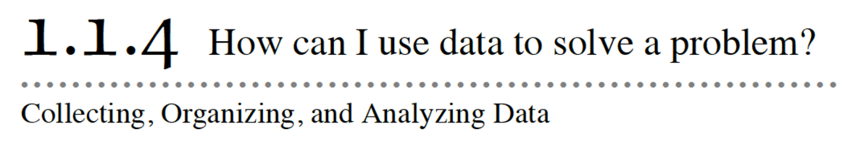

**Chapter 3, Section 1, Part 3:**

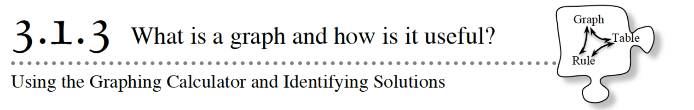

**THE CPM TEXTBOOK**

(you will have a hard copy and you will be able to access it online)

• You can leave your textbook in your locker when you are not using it.

• If you want to bring your textbook to class with you for when we start homework in class, you can; just make sure your name is written in PEN on the front cover in case you leave it in the room by accident.

• To access the textbook online (i.e. a digital version) please do the following:

* Open up any web browser
* Go to **sso.cpm.org**
* This page will pop up, and then you can click the RED “Sign in with Google” button
* You will use your school google email and password from MCMS

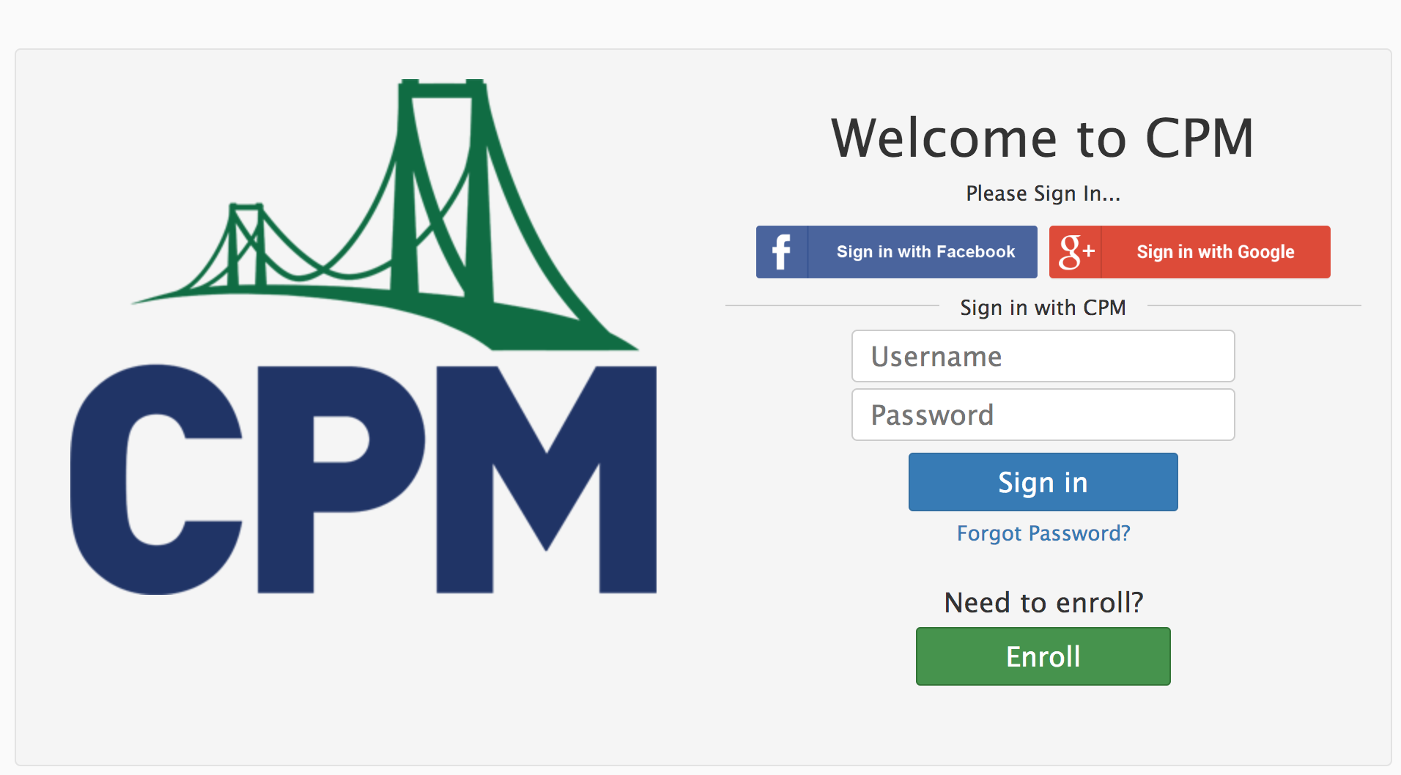

* When you are finished, you can logout by going to the left side of your screen under the CPM bridge logo and clicking on “ **logout ……** ”

If you have trouble logging in throughout the year, please feel free to ask me for help!